上机实验（三）

#include<iostream>

#include<string>

using namespace std;

class Score {

public:

Score()

{

s = 2;

}

Score(int s1) //202030310218李嘉杰

{

s = s1;

}

void InputNameAndScore()

{

int i;

for (i = 0; i < s; i++)

{

cout << "请输入学生姓名:" << endl;

cin >> Name[i];

cout << "请输入科目A成绩:" << endl;

cin >> SScore[i][1];

cout << "请输入科目B成绩:" << endl;

cin >> SScore[i][2];

cout << "请输入科目C成绩:" << endl;

cin >> SScore[i][3];

}

}

void ShowNameAndScore()

{

int i;

for (i = 0; i < s; i++)

{

cout << "姓名: " << Name[i] << " 科目A成绩: " << SScore[i][1] << " 科目B成绩 " << SScore[i][2] << " 科目C成绩: " << SScore[i][3] << endl;

}

}

void ShowStdentAvgScore(int a)

{

float avg = 0;

avg = (SScore[a][1] + SScore[a][2] + SScore[a][3]) / 3;

cout << "姓名: " << Name[a] << " 平均成绩: " << avg << endl;

}

void ShowClassAvgScore(string ClassName)

{

int b;

float avg = 0;

if (ClassName == "A") b = 1;

if (ClassName == "B") b = 2;

if (ClassName == "C") b = 3;

for (int i = 0; i < s; i++)

{

avg = avg + SScore[i][b];

}

avg = avg / s;

cout << "课程名称: " << ClassName << "平均成绩: " << avg << endl;

}

void OrderScore(string ClassName)

{

int b;

if (ClassName == "A") b = 1;

if (ClassName == "B") b = 2;

if (ClassName == "C") b = 3;

for (int i = 0; i < s; i++)

{

SScore1[i] = SScore[i][b];

}

for (int i = 0; i < s; i++)

{

Name1[i] = Name[i];

}

for (int i = 1; i < s; i++)

{

if (SScore1[i] > SScore1[i - 1])

{

float temp = SScore1[i - 1];

SScore1[i - 1] = SScore1[i];

SScore1[i] = temp;

string temp1;

temp1 = Name1[i - 1];

Name1[i - 1] = Name1[i];

Name1[i] = temp1;

}

}

cout << "课程(由高到低排序): " << ClassName << endl;

for (int i = 0; i < s; i++)

{

cout << "姓名: " << Name1[i] << " 成绩: " << SScore1[i] << endl;

}

}

private:

float SScore[100][3], SScore1[100];

string Name[100], Name1[100];

int s;

};

int main()

{

Score S;

S.InputNameAndScore();

S.ShowNameAndScore();

S.ShowStdentAvgScore(0);

S.ShowStdentAvgScore(1);

S.ShowClassAvgScore("A");

S.OrderScore("A");

S.ShowClassAvgScore("B");

S.OrderScore("B");

S.ShowClassAvgScore("C");

S.OrderScore("C");

return 0;

}

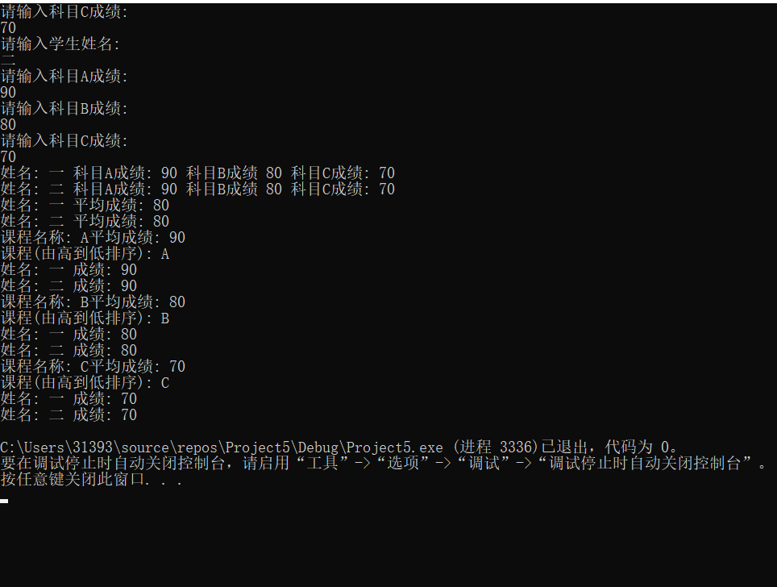

总结：

本次实验让我理解并加深了构造函数和析构函数的定义与作用，也让我理解了为什么吧C++叫做C的延申，这次实验很明显的体现了C++的简洁与高效，尤其是C++中的类这一项，真正的做到了随取随用，大大节省了编程的时间，使整个编程更明了、更简洁。